WOODVILLE LITTLE LEAGUE ID#

3092002
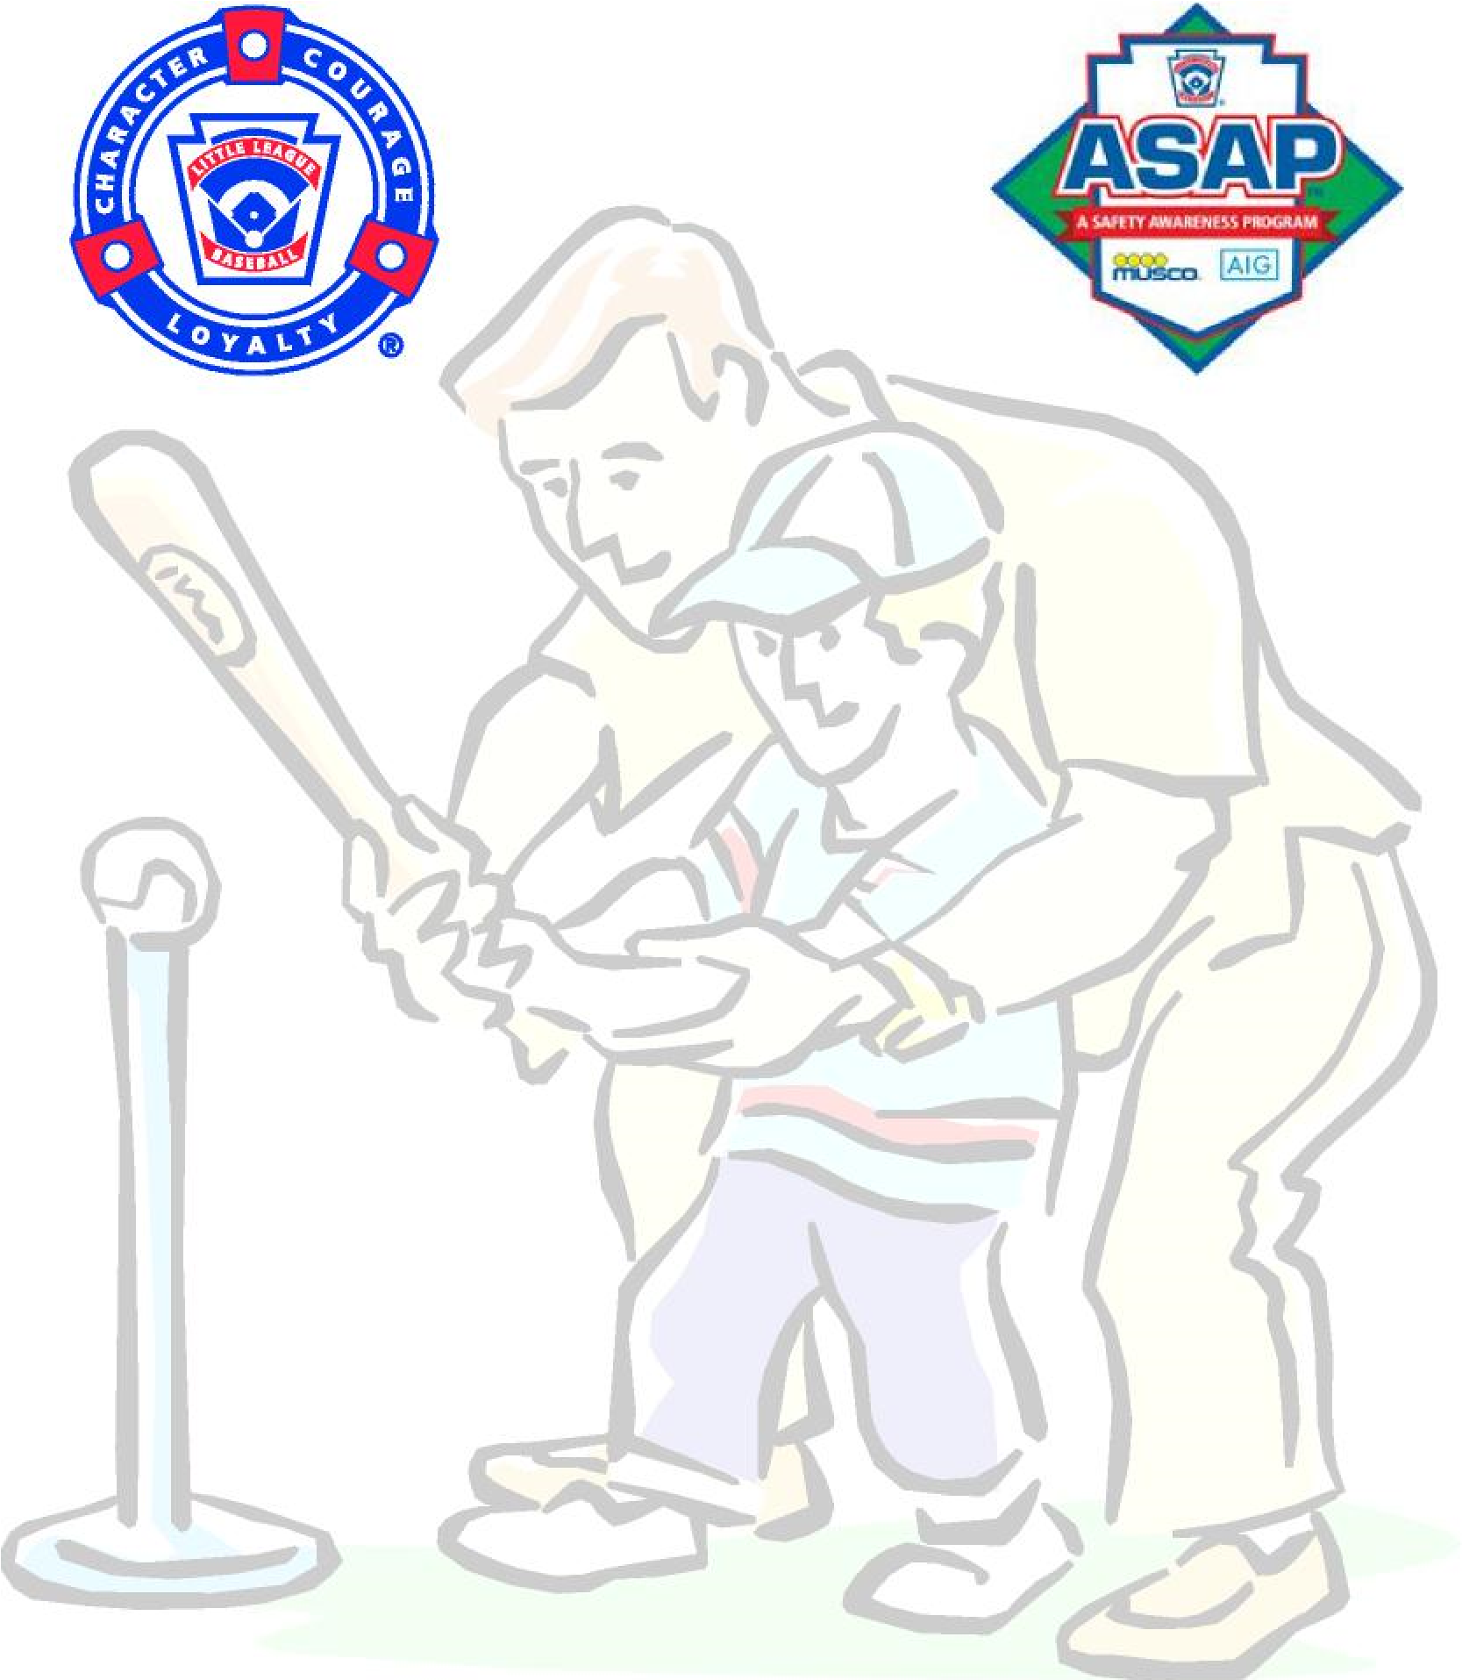
ASAP

(
A SAFETY AWARENESS PROGRAM
)

Together, let’s make
it safer for the kids!

2026

SAFETY PLAN

Woodville Little League 2026 Safety Plan
The goal of the Safety Plan is to develop guidelines for increasing the safety of activities, equipment and facilities through education, compliance and reporting. In support of the attainment of this goal, Woodville Little League (WLL) also commits itself to providing the necessary organizational structure to develop, monitor and enforce the aspects of the plan. WLL also commits to providing annual budget as needed to enforce this plan.
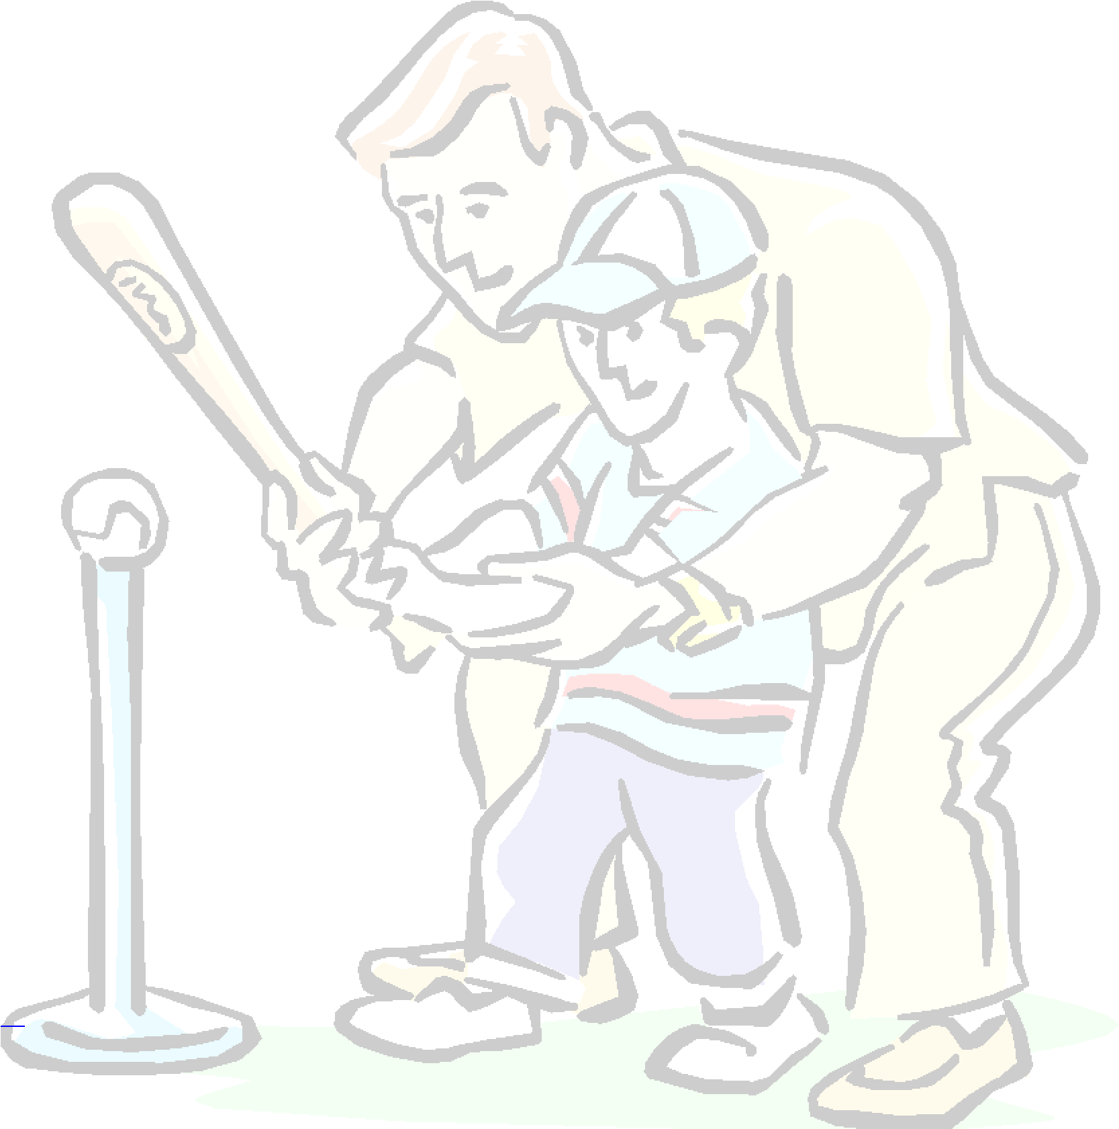
The Safety Plan, by reference, includes the WLL’s Safety Code, the WLL’s Code of Conduct and the WLL’s Safety Manual. The combination of these documents outlines specific safety issues and the WLL’s policy or procedure for each issue. All participants, volunteers, spectators and guests are bound by the guidelines set forth in these documents. All Board members, managers, coaches and umpires shall receive a copy, and a copy will be kept in the concession stands.
The Qualified Safety Plan Requirements Form must be completed and submitted for approval every year by the date listed on the Form.

Safety Officer
One of the elected members on this Board is the Safety Officer. For the 2026 season, the elected Safety Officer is Jessica Cremer. This individual acts as WLL’s primary point of contact for the creation and enactment of the Safety Plan. The Safety Officer authors or modifies the League's Safety Plan, Code of Conduct, Safety Code and
Safety Manual each year, as necessary. These documents are then presented to the Board and District Administrator for approval and ratification for the upcoming season. The Safety Officer is responsible for completing an annual survey of all facilities where games will be played and practices will be held. The Safety Officer will use the form provided by Little League®, submit it to league officials as directed and maintain a copy.
The ultimate responsibility for ensuring compliance of the Safety Plan lies with the managers/coaches, Safety Officer and the WLL Board.

Board Meetings
The Board meets at least once every month. The date and times of Board meetings are published at www.woodvillebaseball.com, and all adults are welcome and encouraged to attend.
The Safety Officer is included on every meeting's agenda. Besides providing an opportunity for the Safety Officer to inform and update the other Board members on the status of certain safety initiatives (whether they be at the local, District or Headquarters level), it also ensures the continued awareness and attention to the subject of safety within WLL.
2026 WLL Safety Plan www.woodvillebaseball.com

2026 WLL Board of Directors

Scott Taranto President | Teressa Wyllie Information Officer
Robert Edwards & Gwen Payne Vice President | Jessica Cremer Safety Officer
Gwen Payne & Teressa Wyllie Treasurer | Raymond Davis  Coaching Coordinator
Jessie Miller  Concession Manager | Jessica Cremer Player Agent
Heather Davis, Samantha Craft  Members at Large | Amber Shiver Secretary

Park Rules
- The speed limit is 5 mph on roadways and in parking lots while attending any WLL function.
- Watch for small children around parked cars.
- No alcohol is allowed in any parking lot, field, or common areas within a WLL complex. A WLL complex is defined as any field where sanctioned WLL games are being played.
- No playing in parking lots at any time.
- No playing on or around lawn equipment.
- Always be alert for traffic.
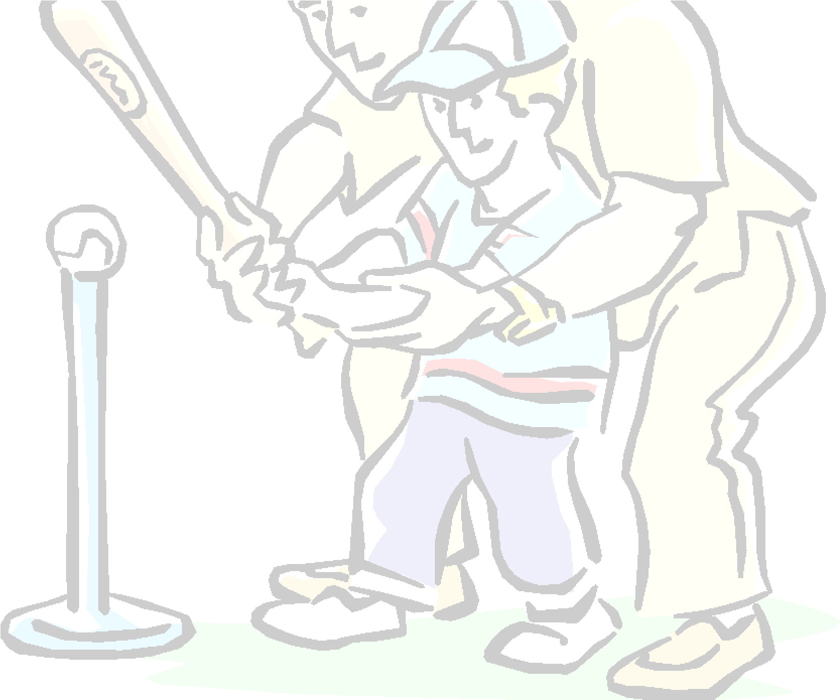
- Scooters, skateboards and roller blades or skates are prohibited on any WLL complex. Bicycles may not be ridden or parked on sidewalks, walkways or common areas of any WLL complex where they may pose a safety hazard.
- No profanity please.
- No intentional throwing of balls against dugouts or against backstops.
- Catchers must be used for all batting practice sessions. Exceptions: Tee-ball, any batting practice using tees or batting cage.
- All gates to playing fields must remain closed at all times. After players have entered or left the playing field, all gates should be closed and secured.
- No children under the age of 16 are permitted in concession stands where high temperature and other dangerous cooking equipment is being used (e.g., grills, fryers, griddles, etc.). For the purpose of this procedure, microwave ovens are not considered hazardous cooking equipment.
- No throwing baseballs at any time within the walkways or common areas of an WLL complex.
- No throwing rocks.
- No horseplay in walkways at any time.
- No climbing fences or walkways guard rails.
- Only a player on the field and at bat may swing a bat (age 3-17). Be alert of area around you when swinging a bat while in the on-deck position.
- WLL recommends the use of face guards and chin straps on all batting helmets and encourages the use of mouth guards.
- Observe all posted signs. Players and spectators should always be alert for foul balls and errant throws.

2026 WLL Safety Plan www.woodvillebaseball.com
- During games, players must remain in the dugout in an orderly fashion at all times.
(Exceptions: Warming up pitcher/catcher and players using the restroom facilities.)
- Players are not to dig holes in the field with their feet. Repeated violation of this rule could result in removal from the game by the umpire in charge.
- After each game, each team must clean up trash in dugout and around stands.
Failure to comply with these rules may result in expulsion from any WLL complex.

Volunteers
The WLL relies on volunteers to perform key functions, including, but not limited to board of directors, managers, coaches, umpires, team parents and concession workers. All volunteers must complete an official Little League® Volunteer Application form and submit a criminal background check. All volunteers must also complete a background screening in accordance with Leon County requirements (i.e., First Choice Background Screening). A list of WLL approved volunteers will be maintained by the President and a copy of this list will be maintained in the concession stand. It is the responsibility of the Umpire-in Chief and the President to ensure that all umpires have met little league standards.

Safety Code
The WLL Safety Code has been adopted by the Board of Directors and is enforced by the Safety Officer, all league officers, participants and volunteers are required to abide by this code. It is the job of the Safety Officer to make any revisions to the Safety Code from year to year, as necessary.

WLL Safety Code
- Responsibility for safety procedures should be that of all adult members of WLL.
- Responsibility for enforcing Little League rules should be that of the umpires and coaches.
- To share news regarding safety issues, the Safety Officer will provide copies of the ASAP (A Safety Awareness Plan).
- Arrangements should be made in advance of all games and practices for emergency medical services.
(The local fire station/ambulance service is within 3 miles of all game fields.)
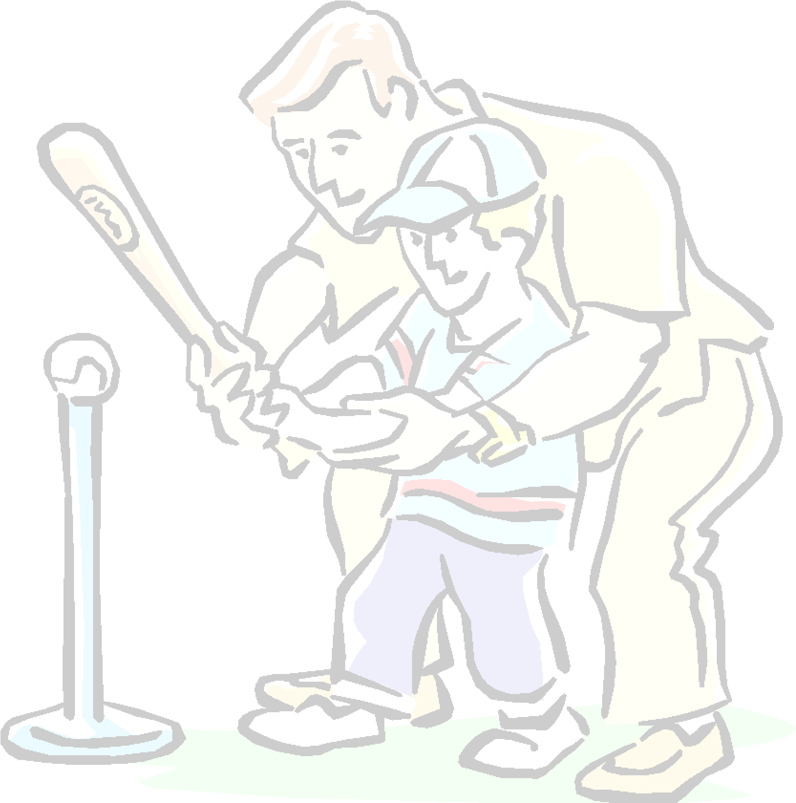
- WLL will provide training in fundamental baseball skills (hitting, sliding, fielding, pitching, etc). All managers, coaches and umpires are required to attend this training at least once every three years, and each team must have at least one participant each year. The Coaching Coordinator is responsible for providing this training and will maintain a record of participants. This training will take place at the Coaches Clinic, at JL Lewis Park on January 21, 2025 at 12:00. Additional meeting dates and times may be available based on needs.
- First-aid kits are in the concession stand.
- No games or practices should be held when weather or field conditions are not good, particularly when lighting is inadequate.
- Play area should be inspected by the coaches before every practice and game for holes, damage, stones, glass and other foreign objects. During games, this responsibility falls on the home team.
- All team equipment should be stored within the team dugout or behind screens and not within the area defined by the umpires as "in play." Responsibility for keeping bats and loose equipment off the field of

2026 WLL Safety Plan www.woodvillebaseball.com
play should be that of a player assigned for this purpose or the team's manager and coaches.
- Only players, managers, coaches and umpires are permitted on the playing field or in the dugout during games and practice sessions. (See Rule 4.05) A designated “Team Parent” may assist in the dugout with Wee Ball and Tee Ball League players. With permission of the umpire in charge, one WLL-approved photographer may be allowed on the field, provided he/she does not interfere with the game in progress.
- Foul balls batted out of the playing area should be returned to the plate umpire.
- During practices and games, all players should be alert and watch the batter on each pitch.
- During warm-up or practice drills, players should be spaced so that no one is endangered by wild throws or missed catches.
- All pre-game warm-ups (e.g., playing catch, pepper, swinging bats, etc.) should be performed within the confines of the playing field or within areas not frequented by spectators.
- Equipment should be inspected by coaches and umpires before every use for the condition of the equipment as well as for proper fit. Equipment problems should be reported to the President or Safety Officer.
- It is the responsibility of the managers and coaches to enforce the use of proper equipment at all times.
n Batters must wear Little League®-approved protective helmets during batting practice and games. Helmets cannot be painted and may not contain tape or decals unless approved in writing by the helmet manufacturer.
- Catcher must wear catcher's helmet, mask, throat guard, long-model (males) or short-model (females) chest protector, shin guards and protective cup with athletic supporter at all times (males) for all practices and games. NO EXCEPTIONS. Players serving to warm up pitchers between innings or in the bullpen must wear catcher's helmet and mask with a throat guard.
- Boys playing other infield positions are strongly encouraged to wear protective cups.
- Managers and coaches are not allowed to catch pitches (Rule 3.09); this includes standing at a backstop during practice as informal catcher for batting practice.
- Except when a runner is returning to a base, head-first slides are not permitted.
- During sliding practice, bases should not be strapped down or anchored.
- At no time should "horseplay" be permitted on the playing field.
- Parents of players who wear glasses are encouraged to provide "safety glasses."
n Players must not wear watches, rings, pins or metallic items during games and practices. (Exception:
jewelry used to identify a medical condition)
- On-deck batters are not permitted except, in the Junior, Senior and Big-League divisions.
n It is recommended that all WLL Board members, coaches and Player Agents be trained in CPR.
- WLL maintains an automatic external defibrillator (AED) which is kept in the concession stand. It is recommended that all WLL Board members, coaches and Player Agents receive AED training - preferably during the League’s first aid training programs.
- Each Player Agent and coach shall appoint a Team Safety Officer to promote safe practices and adherence to WLL’s Safety Plan.
n Wee Ball and Tee Ball Divisions will use Reduced Impact Balls (RIF).

2026 WLL Safety Plan www.woodvillebaseball.com

Batting Cage and Pitching Machine Safety Rules
n Only Player Managers and coaches may check out pitching machines.
n Pitching machines are to be operated by Player Managers and coaches, or other approved adults only.

UNDER NO CIRCUMSTANCES MAY CHILDREN OPERATE PITCHING MACHINES.
- Player Managers, coaches and other adults must receive training by the Board of Directors in the operation of pitching machines before using them.
- Maximum of two people (1 coach and 1 player) in the batting cage at any given time. The batting cage may not be used if not properly equipped with an “L” screen. Adult supervision is required for any use of the batting cage.
- Players must wear Little League®-approved batting helmets upon entering the cage.
- No swinging bats or warm-up swings outside the batting cage. All swings must be inside the cage.
- If a pitching machine is taken onto the playing field, no player will take the pitcher’s position or be in the immediate vicinity of the pitching machine, with the following exception: players in the pitcher’s position during a Machine Pitch or Rookie League practice and/or game shall remain in the circle marked, as prescribed by the respective division rules, for this purpose until the ball is batted into play.
- Players waiting to bat must wait in the dugout until it is his/her turn.
- Batting cage will be closed during scheduled games, except to be used as a bullpen by teams involved in those games.

Bullpen Safety Rules
- Use of bullpen will be on a “first come, first served” basis among teams engaged in scheduled games.
- Before exiting a dugout to use the bullpen, a Coach must receive permission from the umpire in charge.
- When other players and coaches arrive to use the bullpen, those using the bullpen must vacate within 5 minutes.
- All players must be supervised by a Player Agent or coach.
- Only two players in the bullpen at any time. Coaches may not warm up the pitchers (See Rule 3.09).
- Catchers must wear a minimum of Little League®-approved helmet, mask and catcher’s mitt while in the bullpen. Softball catchers must wear approved mask and helmet, but are exempt from using a catcher’s mitt.

Injury-Reporting Procedures
All coaches, parents, umpires and volunteers that are made aware of an injury should use the following reporting procedures.
What to Report - An incident that causes any player, manager, coach, umpire, or volunteer to receive medical treatment and/or first aid must be reported to the Safety Officer. The terms "medical treatment and/or first aid" should include even passive treatments such as the evaluation and diagnosis of the extent of the injury. Any incident that (a) causes a player to miss any practice or game time; or (b) any event that has the potential to require medical assistance must be reported promptly.
NOTE: Only incidents that are related to scheduled practice or games on the field or inside the batting/pitching facilities, and inside the concession stands during scheduled practice or games are considered incidents related to Little League. All other incidents may be reported to the Safety Officer; however, it is strongly recommended that the incident be reported directly to the facility owner (e.g., Leon County)
When to Report - All such incidents described above must be reported to the Safety Officer within 48 hours of the incident. The Safety Officer for 2023 is Lara Barker, and he can be reached at the following:
Phone: 850-688-4084 (cell).

How to Make the Report:
Incidents can be reported in a variety of ways. Most often, they are written reports. At a minimum, the following information must be provided:
- The name and phone number of the individual involved (or of parents).
- The date, time and location of the incident.
- As detailed a description of the incident as possible.
- The preliminary estimation of the extent of any injuries. (Was hospitalization required?)
- The name and phone number of the individual reporting the incident.
- The official forms may be used and are kept in the concession stand but are not required.

In Case of Emergency Call...911
Florida Poison Information Center --------- 1-800-222-1222
Tallahassee Fire Department --------------------- 891-6600
Leon County Sheriff Department ------------------- 922-3300
Tallahassee Police Department --------------------- 891-4200
Tallahassee Memorial Hospital --------------------- 431-1155

Safety Officer's Responsibilities
The Safety Officer will receive this injury report and maintain a record of the incident. Within 48 hours of receiving the incident report, the Safety Officer will contact the injured party or the party's parents and (1) verify the information received; (2) obtain any other information deemed necessary; (3) check on the status of the injured party; and (4) in the event that the injured party required other medical treatment (e.g., Emergency Room visit, doctor's visit, etc.) will advise the parent or guardian of the WLL’s insurance coverage and the provisions for submitting any claims for reimbursement.
If the extent of the injuries is more than minor in nature, the Safety Officer shall periodically call the injured party to (1) check on the status of any injuries and (2) to check if any other assistance is necessary in areas such as submission of insurance forms, etc. until such time as the incident is considered "closed" (i.e., no further claims are expected and/or the individual is participating in the league again).
Further, the Safety Officer will receive reports of all “near-misses” to evaluate in order to avoid potential future accidents and injuries and share them with District staff.
2026 WLL Safety Plan www.woodvillebaseball.com

General Health
® strongly recommends that participants
While physical exams are not required by league policy, Little League be in good general health. If your child has a physical impairment that the league should be aware of, PLEASE note the information on the registration form and contact your league’s Player Agent. Items such as asthma, allergies, eye problems, diabetes, etc., will be kept confidential, except that your child's manager and coach will be aware of any potential problem.

Heat and Hydration
Playing rigorous sports in the heat requires close monitoring of both body and weather conditions. Heat injuries are always dangerous and can be fatal. Children perspire less than adults and require a higher core body temperature to trigger sweating. Heat-related illnesses include dehydration (deficit in body fluids), heat exhaustion (nausea, dizziness, weakness, headache, pale and moist skin, heavy perspiration, normal or low body temperature, weak pulse, dilated pupils, disorientation, fainting spells), and heat stroke (headaches, dizziness, confusion, and hot dry skin, possibly leading to vascular collapse, coma and death). These injuries can be prevented.
- Recognize the dangers of playing in the heat.
- Respond quickly if heat-related injuries occur.
- Schedule regular fluid breaks during practice and games.
- Drinking water is the best choice; others include fruit juices and sports drinks.
- Kids need to drink 8 ounces of fluid every 20 minutes, plus more after playing.
- Make player substitutions more frequently in the heat.
- Wear light-colored “breathable” clothing, and wide-brimmed hats.
- Use misting water sprays on the body to keep cool.
Don’t forget to include sunscreen and a hat to reduce the chance of sunburn, which is actually an injury to the skin. Sun protection may also decrease the chances of malignant melanoma - a potentially deadly skin cancer-or other skin cancers that can occur later in life. It is also important that your child has access to water or a sports drink to stay properly hydrated while playing.

10 Health Tips Every Youth Baseball Coach Should Know
- Stretching the muscles related to the activity is very important. For example, if a child is pitching, he should concentrate on stretching his arm and back muscles. If a child is catching, the focus should be on the legs and back.
- A good warm-up is just as important as stretching. A warm-up can involve light calisthenics or a short jog. This helps raise the core body temperature and prepares all the body’s muscles for physical activity.
- Children should not be encouraged to “play through pain.” Pain is a warning sign of injury. Ignoring it can lead to greater injury.
- Swelling with pain and limitation of motion are two signs that are especially significant in children— don’t ignore them. They may mean the child has a more serious injury than initially suspected.
- Rest is by far the most powerful therapy in youth sports injuries. Nothing helps an injury heal faster than rest.
- Children who play on more than one team are especially at risk for overuse injuries. Overuse injuries are caused by repetitive stress put on the same part of the body over and over again.
- Injuries that look like sprains in adults can be fractures in children. Children are more susceptible to fractures, because their bones are still growing.
- Children’s growth spurts can make for increased risk of injury. A particularly sensitive area in a child’s body during a growth spurt is the growth plate- the area of growth in the bone. Growth plates are weak spots in a child’s body and can be the source of an injury if the child is pushed beyond his limit athletically.
- Ice is a universal first-aid treatment for minor sports injuries. Regular ice packs – no chemical packs should be available at all games and practices. Ice controls the pain and swelling caused by common injuries such as sprains, strains and contusions.
- Always ensure you have a cell phone available at all practices and games.

Treat Injuries with “RICE”
Rest: Reduce or stop using the injured area for 48 hours. If you have a leg injury, you may need to stay off of it completely.
Ice: Put an ice pack on the injured area for 20 minutes at a time 4 to 8 times per day. Use a cold pack, ice bag or a plastic bag filled with crushed ice that has been wrapped in a towel
Compression: Compression of an injured ankle, knee, or wrist may help reduce swelling. These include bandages such as elastic wraps, special boots, air casts and splints. Ask your doctor which one is best. Elevation: Keep the injured area elevated above the level of the heart. Use a pillow to help elevate an injured limb.

Communicable Disease Procedures
While the risk of one participant infecting another with HIV/AIDS during league activities is small, there is a remote risk that other blood-borne infectious disease can be transmitted. Procedures for reducing the potential for transmission of infectious agents should include, but are not limited to the following:
• Routine use of gloves or other precautions to prevent skin and mucous membrane exposure when contact with blood or other body fluids is anticipated.
• Bleeding must be stopped, the open wound covered, and if there is any excessive amount of blood on the uniform, it must be changed before an athlete may participate.
• Immediately wash hands and other skin surfaces if contaminated with blood or other body fluids. Wash hands immediately after removing gloves.
• Clean all blood-contaminated surfaces and equipment with a disinfectant solution or spray (coaches should carry disinfectant to all practices and/or games) before competition resumes.
• Practice proper disposal procedures to prevent injuries caused by needles and other sharp instruments or devices. Although saliva has not been implicated in HIV transmission, to minimize the need for emergency mouth-to-mouth resuscitation, mouthpieces, resuscitation bags, or other ventilation devices could be available for use.
• Managers, coaches, umpires and volunteers with bleeding or oozing skin should refrain from all direct athletic care until condition is resolved.
• Contaminated towels should be disposed of or disinfected properly.
• Follow acceptable guidelines in the immediate control of bleeding and when handling bloody dressings and other articles containing body fluids.

Lightning Evacuation Procedures
- Stop Game/Practice.
- Stay away from metal fencing (including dugouts)!!
- Do not hold a metal bat.
Walk, don't run, to car and wait for a decision on whether or not to continue the game or practice.

Some Important Do's and Don'ts
Do...
- Reassure and aid children who are injured, frightened or lost. Lost children should be escorted to the concession stand.
- Provide, or assist in obtaining, medical attention for those who require it.
- Know your limitations.
- Carry your first-aid kit and medical release forms to all games and practices. ₁₂ n Assist those who require medical attention - and when administering aid, remember to:
- LOOK for signs of injury (blood, black-and-blue deformity of joint etc.).
- LISTEN to the injured describe what happened and what hurts, if conscious.
Before questioning, you may have to calm and soothe an excited child. Feel gently and carefully the injured area for signs of swelling, or grating of broken bone. Make arrangements to have a cellular phone available when your game or practice is at a facility that does not have any public phones.
Don’t...
- Administer any medications. n Provide any food or beverages (other than water).
- Hesitate in giving aid when needed.
- Be afraid to ask for help if you're not sure of the proper procedures (e.g., CPR, etc.). n Transport injured individuals except in extreme emergencies.
- Leave an unattended child at a practice or game. n Hesitate to report any present or potential safety hazard to the Safety Officer immediately.
Remember that safety is everyone’s job. Prevention is the key to reducing accidents to a minimum. Report all hazardous conditions to the Safety Officer or another Board member immediately. Don't play on a field that is not safe or with unsafe playing equipment. Be sure your players are fully equipped at all times, especially catchers and batters. And, check your team's equipment often.

2026 WLL Safety Plan www.woodvillebaseball.com

Concession Stand Procedures
Post these procedures in a conspicuous place in the concession stand.
- No individuals under the age of 16 are permitted in the concession building or outside cooking areas, unless high temperature and other hazardous cooking equipment are not being used (e.g., grills, fryers, griddles, etc.). For the purpose of this procedure, microwave ovens are not considered hazardous cooking equipment.
- The concession door must remain closed at all times when the stand is in operation.
n No grill cooking is to be done within the confines of the concession building.
- All grilling and frying will be done within a designated area.
n No hazardous materials may be stored in the concession stand.
- Gas grills, fish cookers and spare propane tanks are to be stored in the concession’s storage room. All gas tanks are to be securely turned off at the bottle when not in use and preferably locked if possible.
- Concession stand manager(s) should be trained in safe food-handling and preparation.
n All volunteer concession workers must wash hands thoroughly before serving patrons.
- Any volunteer concession workers that will be handling “open” food, such as hot dogs, must wear gloves.
- Workers handling money should not handle “open” food until it is properly packaged.
n All concession managers must be trained in safe food handling/preparation and procedures.

Copies of the Code of Conduct, the Safety Code and the Manager's Expectations are provided to each manager. It is expected that the manager will provide each member of his or her team with a copy of each of these.
The Code of Conduct and the Safety Code were listed previously in this document. The Manager's
Expectations can be found below. The Manager’s Expectations passage will be posted on the WLL Web site. Managers are encouraged to share this document with players and their parents.

Little League® Data Center – Players, Managers, and Coaches
The following information will be submitted to Little League as required by the approved ASAP Plan in 2021:
- Manager and Coaches data.
- League player registration data or player roster data.

2026 WLL Safety Plan www.woodvillebaseball.com

Little League Pledge
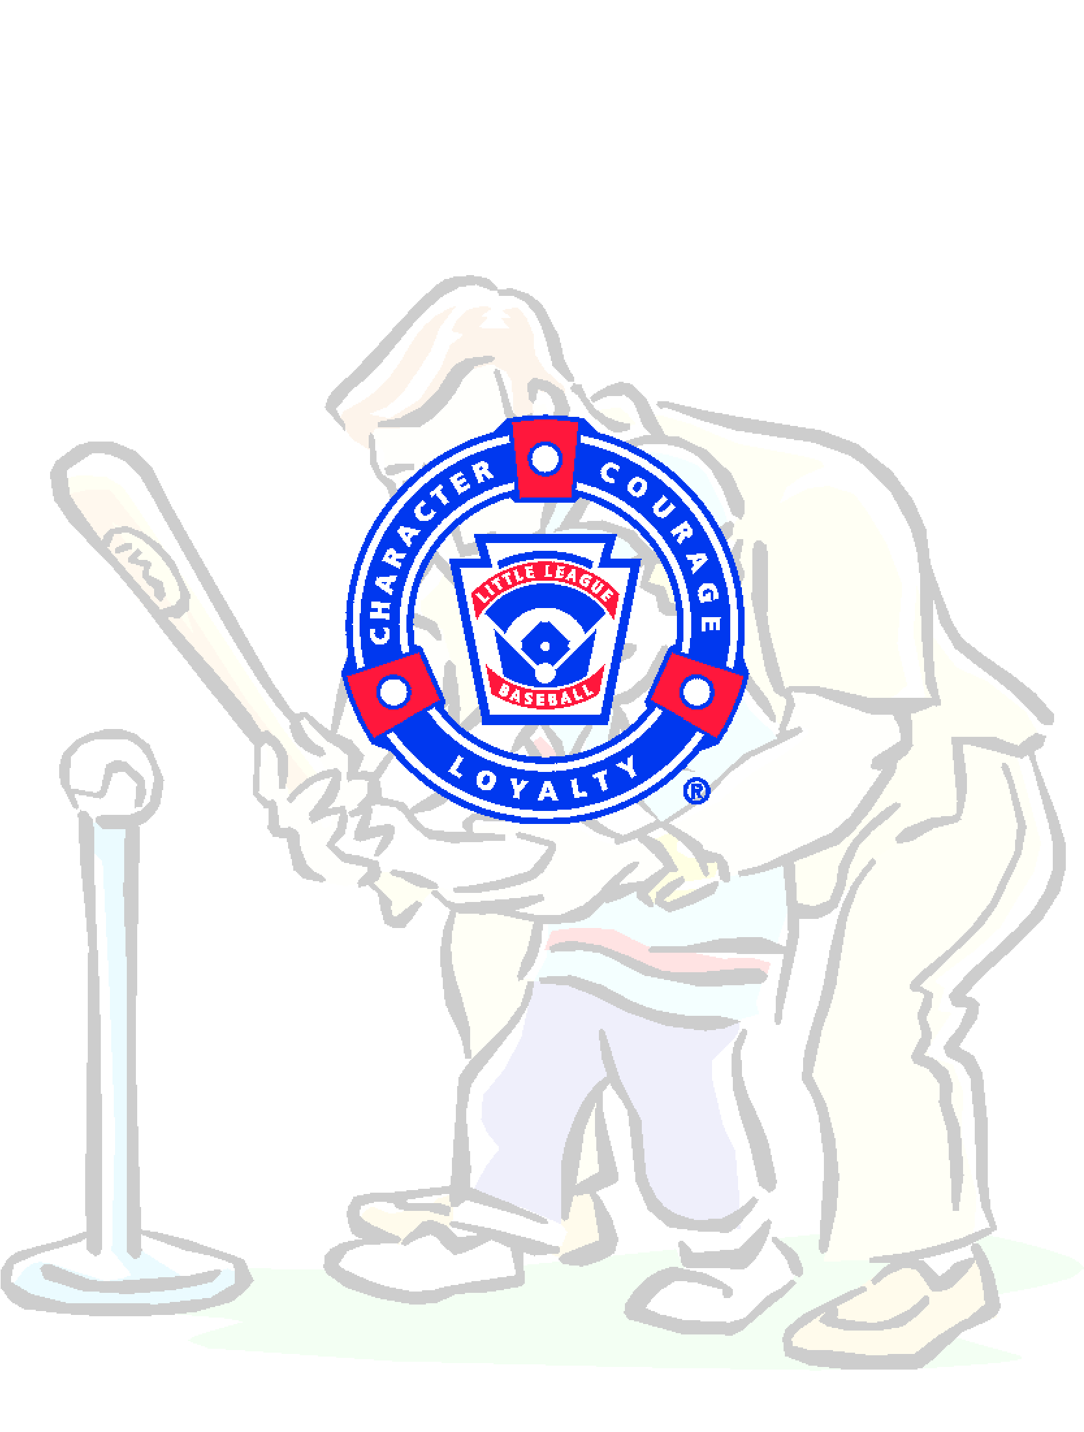

I will teach all children to play fair and do their best

I will positively support all managers, coaches and players
I will respect the decisions of the umpires

I will praise a good effort despite the outcome of the game

From the ranks of youngsters who stand now
on the morning side of the hill

will come the leaders, the future strength

and character of the nation

The Little League
Parent/Volunteer Pledge

I TRUST IN GOD

I LOVE MY COUNTRY

AND WILL RESPECT ITS LAW
S
I WILL PLAY FAIR

AND STRIVE TO WIN

BUT WIN OR LOOSE

I WILL ALWAYS

DO MY BEST

2026 WLL Safety Plan www.woodvillebaseball.com

